Selenium class note

Why selenium is so popular ?

Because that is free and every system and browser can run ,QTPis expensive and also not able to run on the Safari and Firefox Browser ,

Selenium is a tool but not a tool just a jar file , as we dowland it .

Selenium can work as the system like , Windows , linux , OS x , solaris ,

The browsers ; IE , chroome , Safari , firefox ,and every language can use to run .

And also if we what to use selenium the easy way is dowland the selenium then under the eclipse we just need to do is ,open the project properites celect build java path select libraries tap select add external jar make sure to choose every jar file in the selenium . after that we have the connection .

1.Using selenium to open browser we need to open javadoc under doc we can find webdriver interface , and every browser as mean ChromeDriver , FirefoxDriver , InternentExploreDriver…..

2.Webdriver.chrome.driver (C:\Users\chromedriver.exe) this is the path

This is using system.getproperty it means we can find the property we want to use , for that we have to give the path ,

Before that if we want to use chromeDriver we have to dowland ,then find the path of that chromeDriver

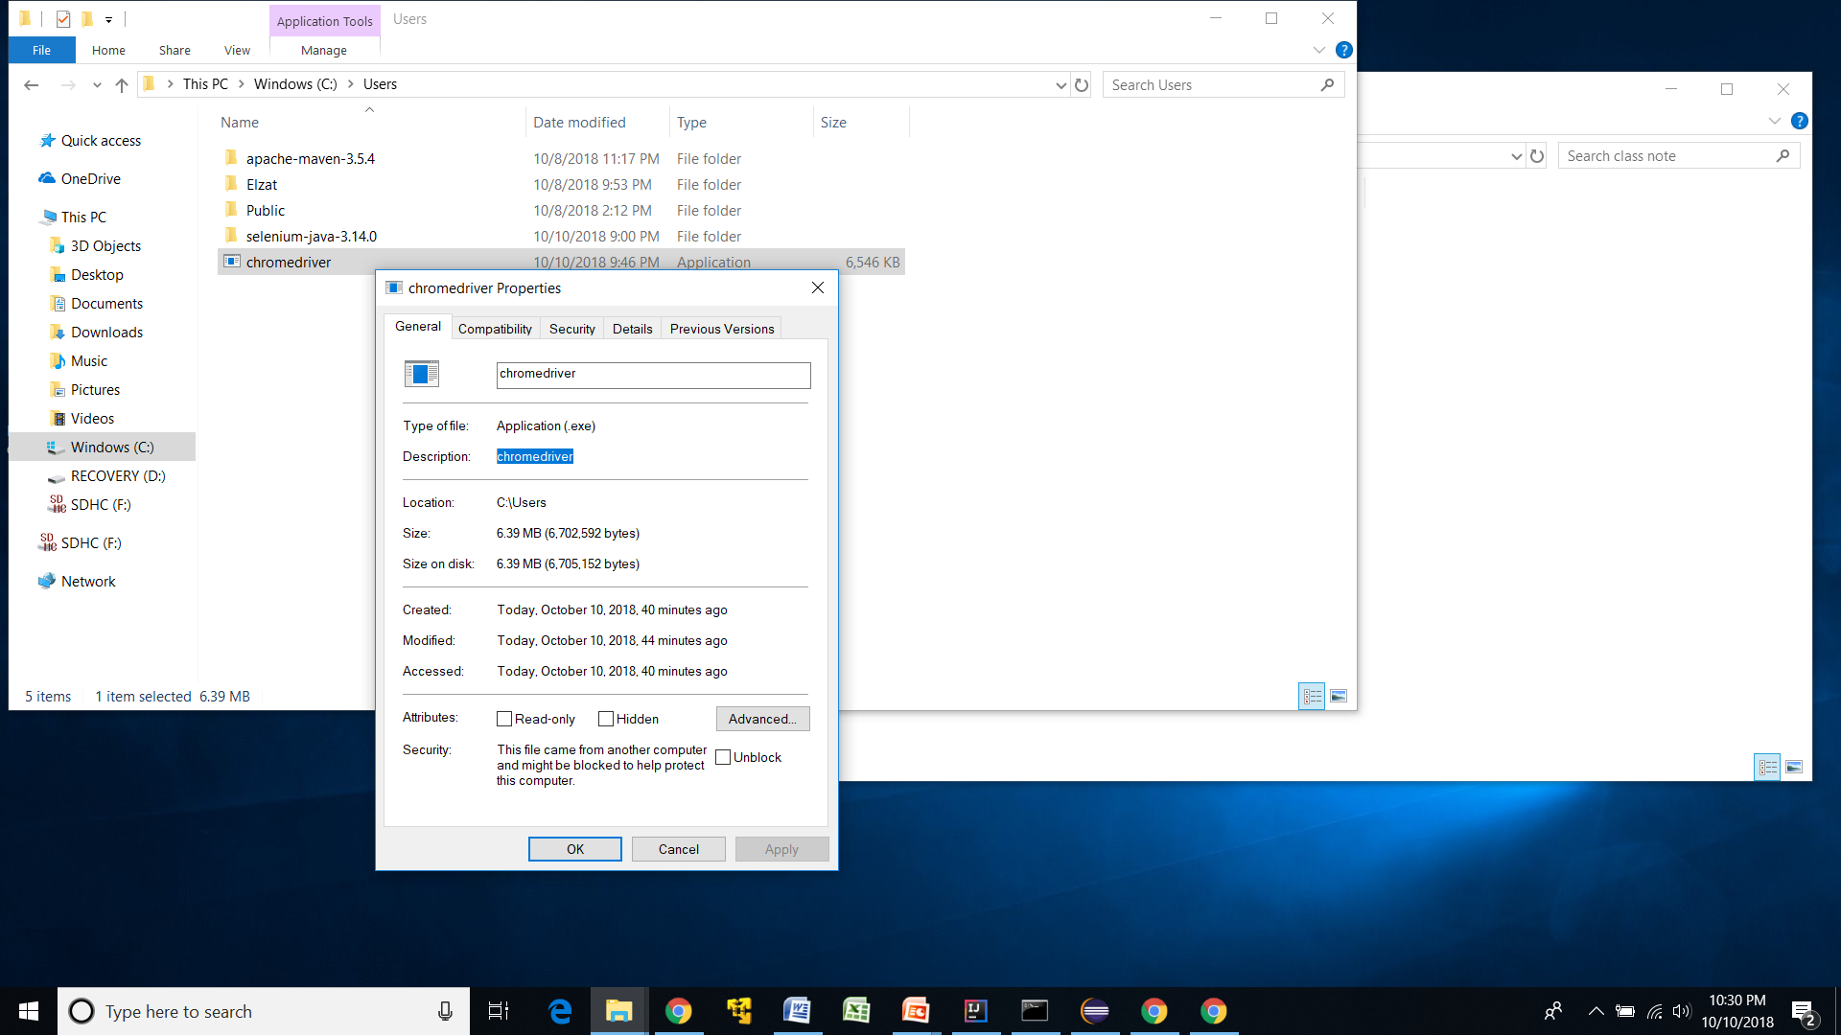

Path would be (C:\Users\ chromedriver.exe) make sure to find the right path

**For Chrome**

**System.setProperty(“webdriver.driver.chrome” , “C:\\Users\\ chromedriver.exe”);**

**WebDriver driver = new ChromeDriver();**

**Driver.get(**[**http://www.google.com**](http://www.google.com)**);**

**System.out.println(driver.getTitle());**

**For IE**

**First we need to set property , this time is for ie , so we need to dowland third part for Internet Explorer ,MicrosoftEdgeDriver , then find the path , key will be webdriver.ie.driver , the path .**

**webDriver driver = new InternetExploreDriver**

**System.setProperty(“webdriver.ie.driver”,** “C:\\Users\ \Microsoft Web Driver.exe”);

webDriver driver = new **InternetExploreDriver():**

**driver.get(**[**http://www.google.com**](http://www.google.com)**);**

**System.out.println(driver.getTitle());**

**For Firefox**

**First go to javadoc find the FirefoxDriver class ,**

**Next dowland thirdpart MozillaGeckoDriver ,then find the right path.**

**System.setPropery(webdriver.gecko.driver, C:\\Users\ \geckodriver.exe);**

**WebDriver driver = new FirefoxDriver();**

**Driver.get(**[**http://www.google.com**](http://www.google.com)**);**

**System.out.println(driver.getTitle());**

Webdriver.ie.driver (C:\Users\ Microsoft Web Driver.exe)

Webdriver.gecko.driver(C:\Users\ geckodriver.exe)

**Method**

There is some method we know from the class , if we want to know can we in the right url , we can use getCurretUrl() method , if we writing

**getCurrentUrl();**

System.out.println(driver.getCurrentUrl()); it will show the current url we are login .

**getPageSource();**

Other method is if we want to get the page source we can use , getPageSource method , System.out.println(driver.getPageSource());

Most of the webside we can get page source just right click, some bank webside don’t allow user right click , at that case we can use getPageSource , it will give us page source .

Driver.get(<http://www.facebook.com>); it will open new url .

Driver.navigate().back(); the new url open and back to the first url.

Driver.close(); it will close the browser we open.

Driver.quit(); it will close all of the browser open by selenium scipt.

**Locate the WebElement :**

* ID
* Name
* ClassName
* LinkText
* Xpath
* Css

Using these to find the locate of that element . if we want to find element by ID

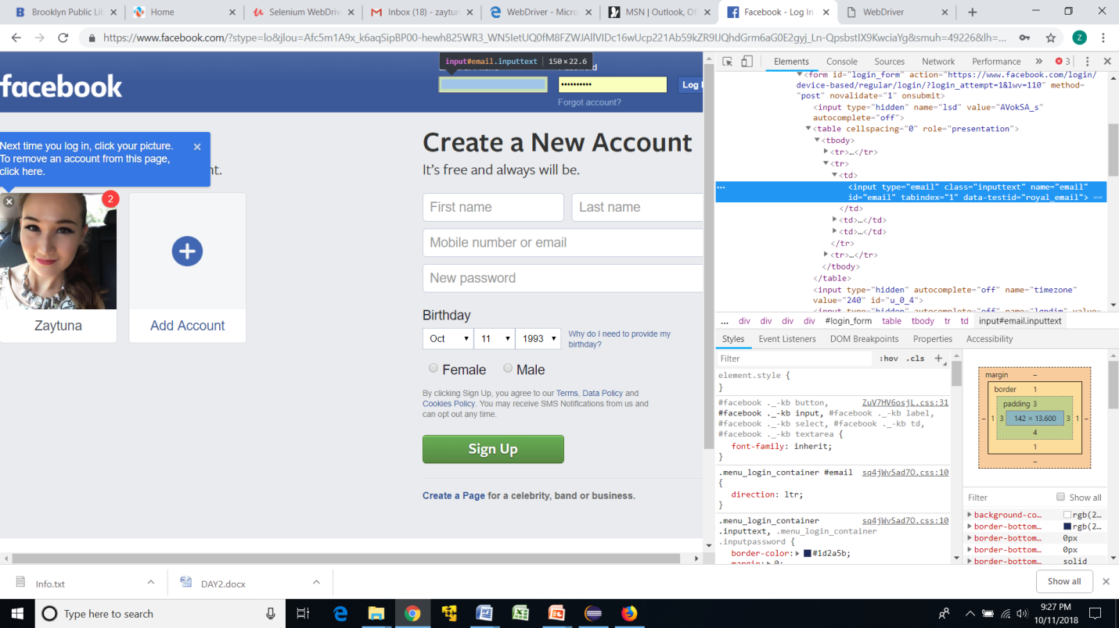

As we see there is id = “email” so that block we can locate element by id , code is : driver.findElement(By.id(“email”)).sendKeys(“zaytuna128@gmail.com”)

After the sendKeys is the massage we want to put into that block .

In the real work most commonly use is Xpath and Css for locate the WebElement , because most of the time WebElement may not have ID , Name ,ClassName and Linkext , at that time we can use Xpath or Css . also may the client require locate the element by Xpath or Css .

Alpha numeric Id maybe change every time we refresh the url . so Id is like u-o-2 like this we cannot located by ID.

Confirm the link object we can use linkText , confirm the link object with anchot “a” tag .

**By ID**

The method is driver.findElement(By.id(“email”)).sendKeys(“[zaytuna128@gamil.com](mailto:zaytuna128@gamil.com)”);

**By Name**

Driver.findElement(By.name(“pass”)).sendKeys(“12346”);

**By linkText**

Driver.findElement(By.linkText(“forget password”)).click();

**By ClassName**

Driver.findElement(By.ClassName ()).sendKeys in this case we not use class name has space , compound class cannot be accepted .

//*[@id="u_0_2"] //*[@id="Login"] //*[@id="u_0_2"]

1. //*[@id="u_0_2"]

**Find WebElement depending on Browsers**

**Xpath**

Find WebElement using Xpath , using Xpath we can find WebElement by using Xpath , chrome and firefox browser offer you the xpath for the WebElement , so we can able to find that in the easy way ,

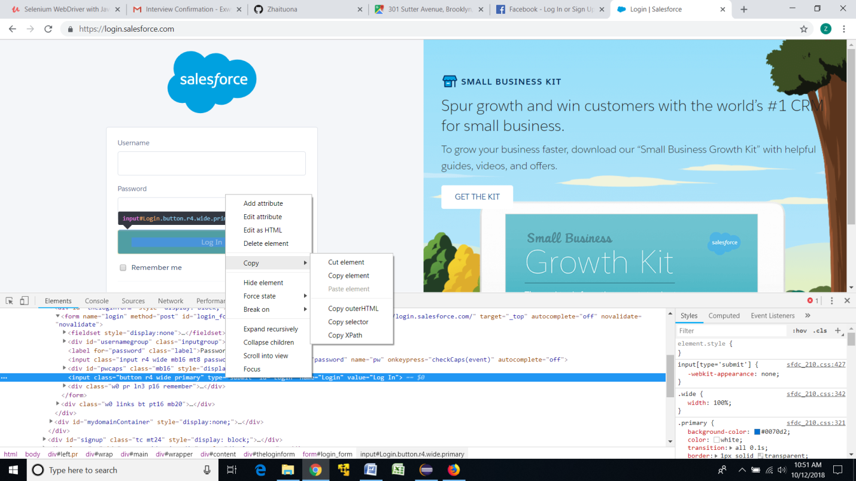

We can find the Xpath like this very easy and clear , but when we write the code , there is very important thing we must do is change qoertation**. If we copy the Xpath for login botton , we copy like this , //*[@id="Login"], but in the java , we need put this in to the String , java don’t allaw us use double quotes inside double quotes , so we can change that //*[@id=’Login’] .very important .**

**Xpath can be defied in n mumber of ways .**

**IE dose not support HTML , so we cannot inspect like other browsers .**

//*[@id="u_0_2"] right now is working .

**Same webElement find from browser Xpath it will show different Xpath, so sometimes not stable giving Xpath from the Firefox Browser .**

/html/body/div[1]/div[2]/div/div/div/div/div[2]/form/table/tbody/tr[3]/td[2]/div/a firefox

//*[@id="login_form"]/table/tbody/tr[3]/td[2]/div/a chrome

//*[@id="login_form"]/table/tbody/tr[3]/td[2]/div/a

**Css**

We can find WebElement by Css , the way is

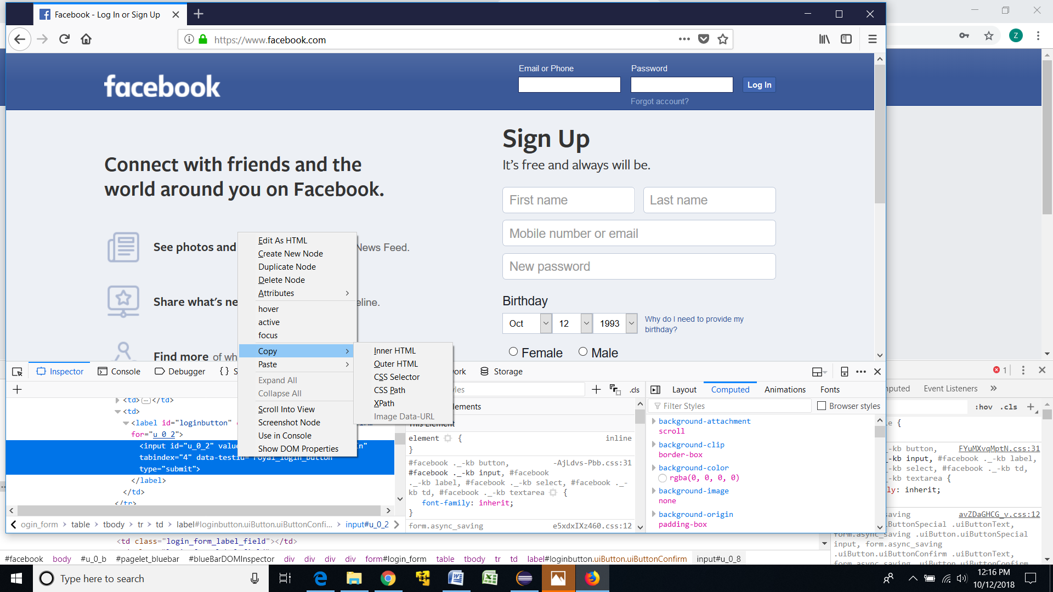

If we want to find the log in button from Css , so we can right click the Copy then click CSS Selector , then copy css , then use , this is for Firefox Browser , different to the Chrome browser ,

For chrome 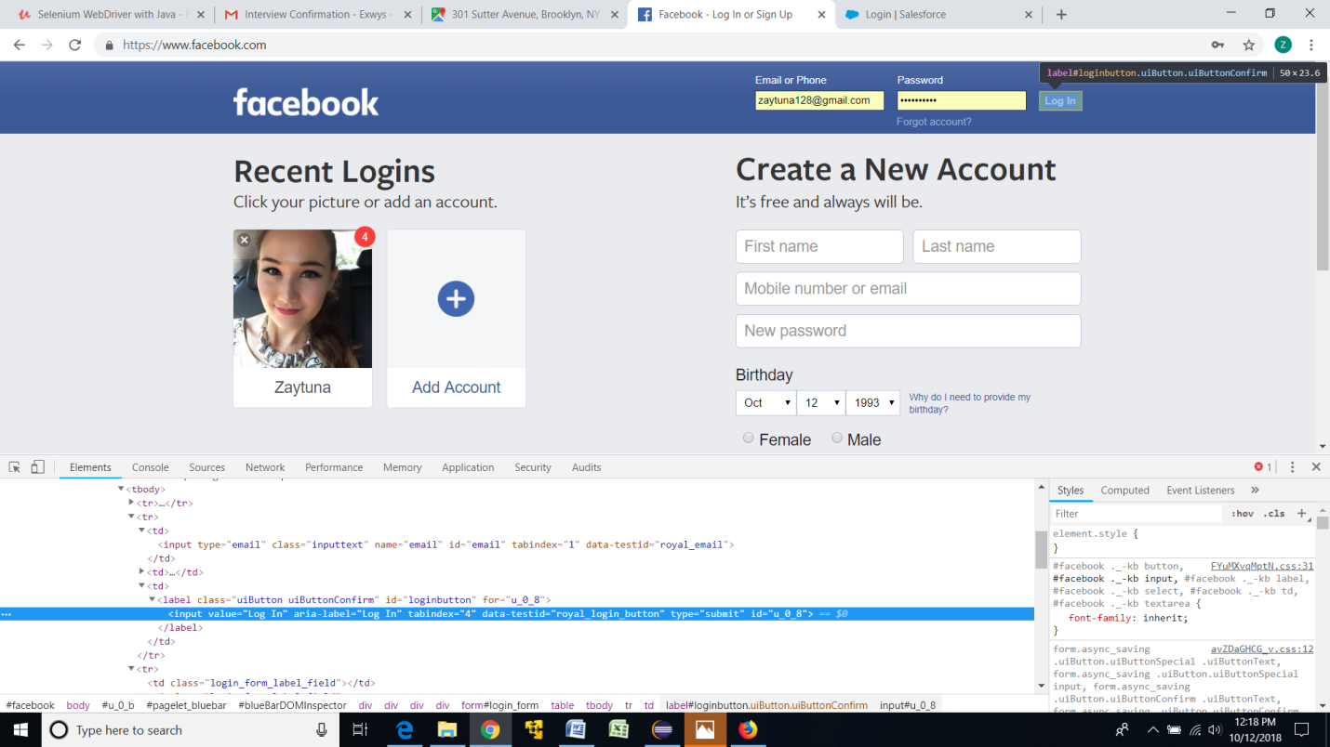

From Css chrome dose not have css selector , so we can find from under to change .

**IE internet explore**

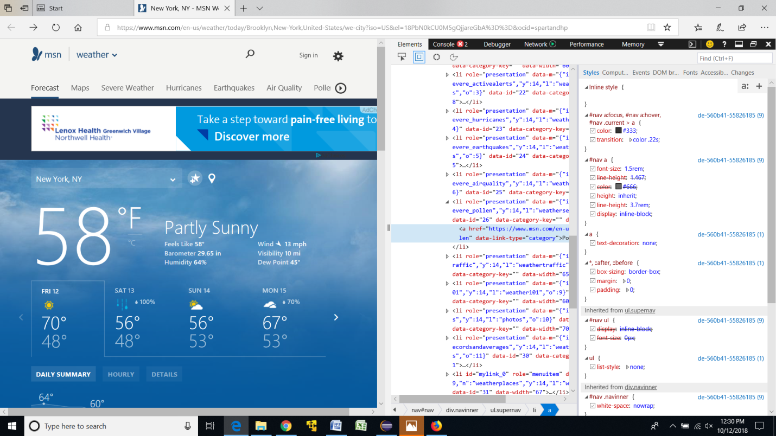

IF we want to locate webElement from IE we need to click …, then click developer tools then able to inspect webelement .

**This steps just easy way to find Xpath and Css from browser , but in the real work we need to know customize the Xpath and Css . easy way can be use for practise .**

**//*[@id="Login"] //*[@id="email"] //*[@id="u_0_8"]**

**Validate Css and Xpath before we using Bowser tools to get the Xpath and Css for the WebElement .**

**How can we validate ?**

**By Firefox Browser**

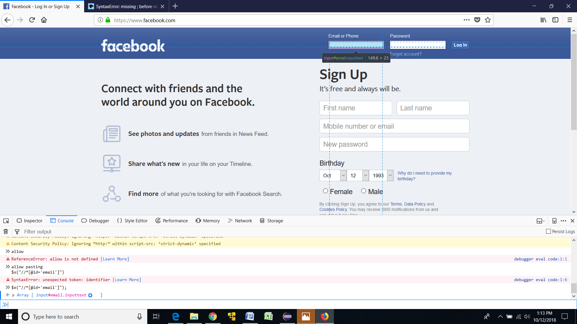

**Click the webElement we want to locate the click inspect the click , copy ,copy Xpath , then click console , first time we want to use than enter allow pasting . then if we locate the element by Xpath $x(“copy the Xpath here , must change the quortation”), end with ;.**

**By Css $(“ copy that Css“) ,**

**For Chrome Browser it will showing like this .**

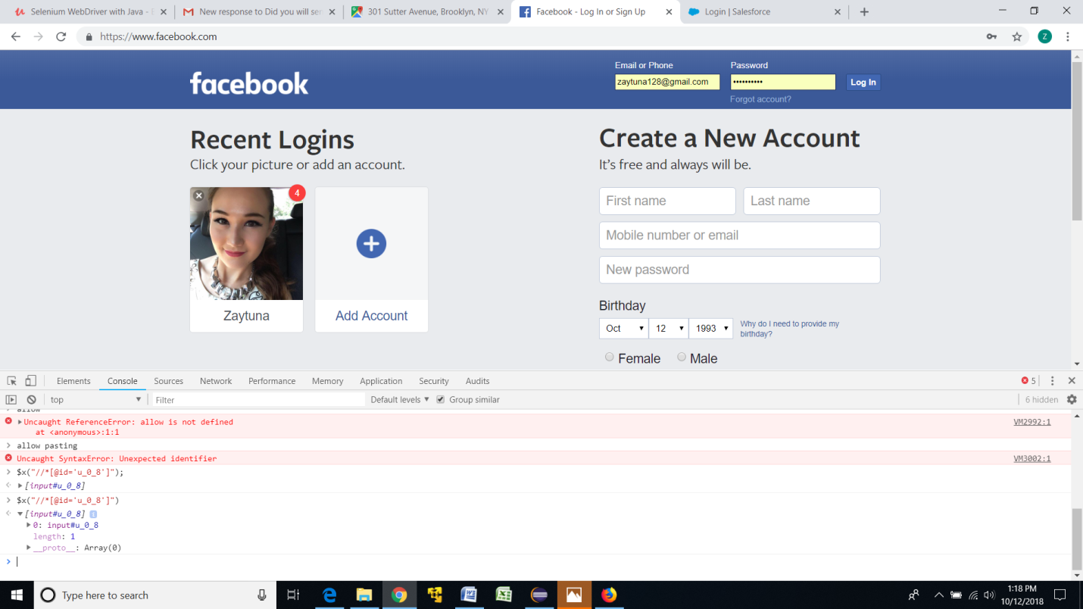

**By Xpath $x(“copy the path”); end with ;**

**By Cs $(“ copy the path“)**